UNITED STATES

SECURITIES AND EXCHANGE COMMISSION

Washington, D.C. 20549

FORM 8-K

CURRENT REPORT

Pursuant to Section 13 or 15(d) of

the Securities Exchange Act of 1934

Date of Report (Date of earliest event reported): June 29, 2026

Paramount Skydance Corporation

(Exact name of registrant as specified in its charter)

Delaware | 001-42791 | 99-3917985
(State or other jurisdiction of | (Commission File Number) | (IRS Employer Identification
incorporation) |  | Number)
1515 Broadway
New York, New York |  | 10036
(Address of principal executive offices) |  | (Zip Code)

Registrant’s telephone number, including area code: (212) 258-6000

Not Applicable

(Former name or former address, if changed since last report)

Check the appropriate box below if the Form 8-K filing is intended to simultaneously satisfy the filing obligation of the registrant under any of the following provisions:

- Written communications pursuant to Rule 425 under the Securities Act (17 CFR 230.425)

- Soliciting material pursuant to Rule 14a-12 under the Exchange Act (17 CFR 240.14a-12)

- Pre-commencement communications pursuant to Rule 14d-2(b) under the Exchange Act (17 CFR 240.14d-2(b))

- Pre-commencement communications pursuant to Rule 13e-4(c) under the Exchange Act (17 CFR 240.13e-4(c))

Securities registered pursuant to Section 12(b) of the Act:

Title of each class |  | Trading Symbol(s) |  | Name of each exchange on which registered
Class B Common Stock, $0.001 par value |  | PSKY |  | The Nasdaq Stock Market LLC

Indicate by check mark whether the registrant is an emerging growth company as defined in Rule 405 of the Securities Act of 1933 (§230.405 of this chapter) or Rule 12b-2 of the Securities Exchange Act of 1934 (§240.12b-2 of this chapter).
Emerging growth company ☐

If an emerging growth company, indicate by check mark if the registrant has elected not to use the extended transition period for complying with any new or revised financial accounting standards provided pursuant to Section 13(a) of the Exchange Act. ☐

Item 8.01 Other Events

On July 21, 2026, Paramount Skydance Corporation (“Paramount”) will hold its 2026 annual meeting of stockholders (the “Annual Meeting”). The purpose of the Annual Meeting is described in the information statement for the Annual Meeting attached as Exhibit 99. Paramount stockholders can access the meeting on Paramount’s Investors homepage at ir.paramount.com beginning at 8:30 a.m. (PT) / 11:30 a.m. (ET).

 | Item 9.01 |  | Financial Statements and Exhibits.
(d) Exhibits.
 | Exhibit |  | Description of Exhibit
 | Number
 | 99 |  | Information Statement for the 2026 Annual Meeting of Stockholders.
104 |  |  | Cover Page Interactive Data File (embedded within the Inline XBRL document).

SIGNATURE

Pursuant to the requirements of the Securities Exchange Act of 1934, as amended, the registrant has duly caused this report to be signed on its behalf by the undersigned hereunto duly authorized.

PARAMOUNT SKYDANCE CORPORATION

By: /s/ Makan Delrahim

Name: Makan Delrahim

Title: Chief Legal Officer

Date: June 29, 2026

Exhibit 99

June 29, 2026

2026 Annual Meeting of Stockholders, To be Held on July 21, 2026

Dear Paramount Stockholder:

The 2026 Annual Meeting of Stockholders (the “Annual Meeting”) of Paramount Skydance Corporation (“we”, “us”, “our”, “Paramount” or the “Company”) will be held by live webcast on July 21, 2026 at 8:30 a.m. Pacific Time (11:30 a.m. Eastern Time). The Annual Meeting is being held to afford stockholders the opportunity to discuss Company affairs with management and for us to present the results of the following pending matters before stockholders by written consent:

- The election of the ten director nominees identified in the accompanying Information Statement for the 2026 Annual Meeting of the Stockholders (“Information Statement”); and

- The ratification of the appointment of PricewaterhouseCoopers LLP to serve as our independent registered public accounting firm for fiscal year 2026.

These matters are more fully described in the Information Statement.

Holders of our Class A Common Stock as of the close of business on June 30, 2026 may vote on any matters pending before our stockholders. Holders of our Class B Common Stock are not entitled to vote on the pending matters.

Stockholders holding a majority of the voting power of our Class A Common Stock have indicated that they intend to act by written consent to vote FOR each of the proposals identified above.

Makan Delrahim

Chief Legal Officer

WE ARE NOT ASKING YOU FOR A PROXY AND

YOU ARE REQUESTED NOT TO SEND US A PROXY
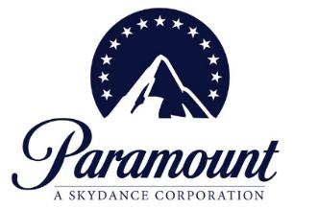

Information Statement for the 2026 Annual Meeting of Stockholders

INFORMATION REGARDING THE MEETING

This information statement (“Information Statement”) is being made available to our stockholders to provide information regarding our 2026 annual meeting of stockholders (“Annual Meeting”) to be held on Tuesday, July 21, 2026 at 8:30 a.m. Pacific Time by live webcast at ir.paramount.com.

Additional information about the meeting is included below under “Questions and Answers about this Information Statement and the Annual Meeting.”

Harbor Lights Entertainment, Inc., and its two wholly-owned subsidiaries (collectively, “Harbor Lights”) hold 100.0% of the Paramount Skydance Corporation Class A Common Stock.

We have been informed that Harbor Lights intends to act by written consent to vote their shares of Class A Common Stock: (1) “FOR” the election of each of the director nominees named in this Information Statement; and (2) “FOR” ratification of the appointment of our independent public accounting firm for fiscal year 2026. Accordingly, we expect Proposals 1 and 2 to be approved by written consent of the holders of our Class A Common Stock prior to the meeting.

Because our directors will be elected by written consent, and not at the meeting, our Annual Meeting is not expected to be an annual meeting of stockholders under the Delaware General Corporation Law. For all other purposes, we will treat the meeting as our annual meeting of stockholders.

Stockholders may submit questions to management in advance of the meeting by sending them to AnnualMeeting@paramount.com on or before July 7, 2026.

QUESTIONS AND ANSWERS ABOUT THIS INFORMATION STATEMENT AND THE ANNUAL MEETING

- Why is the Information Statement being provided? Is the Board of Directors of Paramount Skydance Corporation soliciting my proxy?

This Information Statement is being made available to you for informational purposes only. It addresses how to attend the Annual Meeting and submit questions in advance and includes information regarding the matters pending before stockholders, which we expect to be approved by written consent prior to the Annual Meeting.

Our Board of Directors is not asking you for a proxy or consent in connection with the pending matters and you are requested not to send us a proxy.

Q: How do I attend the Annual Meeting?

The Annual Meeting is scheduled to be held by live webcast at 8:30 a.m. Pacific Daylight Time on July 21, 2026. The Annual Meeting may be attended by visiting our Investors homepage at ir.paramount.com at the designated time. We encourage you to access the meeting shortly prior to the start time.

Q: Why is Paramount holding an Annual Meeting?

The Annual Meeting is being held to give stockholders the opportunity to discuss Company affairs with management and for

Paramount to present the results of the following pending matters before stockholders by written consent:

  - The election of the ten director nominees identified in this Information Statement; and

  - The ratification of the appointment of PricewaterhouseCoopers LLP (“PwC”) to serve as our independent registered public accounting firm for fiscal year 2026.

- Who can vote on the pending stockholder matters? Can I vote at the Annual Meeting?

No vote will be held at the Annual Meeting. Instead, our management, at the direction of our Board of Directors, will solicit approval of the pending stockholder matters by written consent of the holders of our Class A Common Stock.

Harbor Lights holds 100.0% of the Paramount Skydance Corporation Class A Common Stock. David Ellison, by virtue of his role as manager of certain limited liability companies that are directly and indirectly controlled by the Ellison family, may be deemed to control Harbor Lights Entertainment, Inc. and, as a result, may be deemed to beneficially own the shares of Class A Common Stock held of record by Harbor Lights, and to have shared voting and investment power over these securities.

We have been informed that Harbor Lights intends to act by written consent to vote their shares of Class A Common Stock in favor of the pending matters. Accordingly, we expect Proposals 1 and 2 to be approved by stockholder written consent prior to the meeting.

Q: How do I submit questions for the Annual Meeting?

All stockholders, including holders of our Class A and Class B Common Stock, may submit questions to management in advance of the meeting by sending them to AnnualMeeting@paramount.com on or before July 7, 2026. Questions should be succinct and

only cover a single topic. Each stockholder is limited to no more than two questions. We will not address questions that are, among other things:

  - irrelevant to Paramount’s business;

  - related to the pending merger with Warner Bros. Discovery Inc.;
  - related to material non-public information of the Company, including the status or results of our business since our last Quarterly Report on Form 10-Q;
  - related to any pending, threatened or ongoing litigation;
  - related to personal grievances;

  - derogatory references to individuals or that are otherwise in bad taste;
  - substantially repetitious of questions already made by another stockholder;

  - in excess of the two question limit;

  - in furtherance of the stockholder’s personal or business interests; or
  - out of order or not otherwise suitable for the conduct of the Annual Meeting as determined by management in their reasonable judgment.

- How will stockholders know if the pending stockholder matters were approved?

We expect to announce whether the pending stockholder matters were approved by stockholder written consent at the Annual Meeting. Such results will also be published in a filing with the SEC.

PROPOSAL 1 – ELECTION OF DIRECTORS

Our Board of Directors has nominated, and recommended that our stockholders elect, the ten director nominees identified in this Information Statement, all of whom are current members of our Board. Each director elected by stockholder written consent will hold office, in accordance with our Amended and Restated Certificate of Incorporation and Amended and Restated Bylaws, until the annual election of directors by stockholders or until his or her successor is duly elected and qualified.

Each of the director nominees has indicated that he or she will be able to serve if elected and has agreed to do so.

The Board’s nominees for election are: David Ellison, Andrew Brandon-Gordon, Barbara M. Byrne, Andrew Campion, Gerald Cardinale, Safra A. Catz, Justin G. Hamill, Sherry Lansing, Paul Marinelli, and John L. Thornton.

The following are biographies describing the backgrounds of our director nominees:


DAVID ELLISON

Mr. Ellison has served as our Chairman and Chief Executive Officer since August 2025. Prior to becoming Chief Executive Officer of Paramount, Mr. Ellison served as founder and Chief Executive Officer of Skydance Media, LLC (“Skydance”) since 2010. Mr. Ellison is also on the board of advisors of the Ellison Institute, LLC and the board of directors of Harbor Lights Entertainment, Inc. We believe Mr. Ellison is qualified to serve as a member of our Board because of his significant experience in the entertainment and media industry and deep knowledge of Skydance’s business as founder and Chief Executive Officer of Skydance.

Chairman of the Board and

Chief Executive Officer

Age: 43

Director since: 2025

Committees: N/A
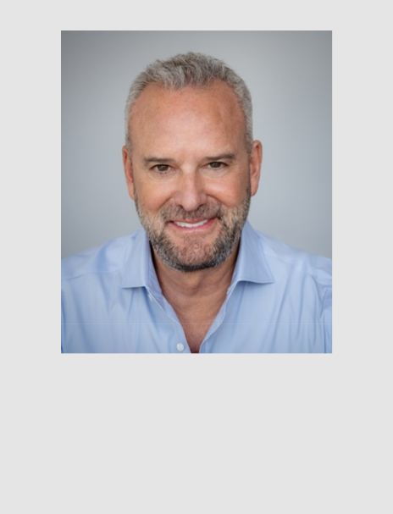

Chief Strategy Officer,

Chief Operating Officer and Director Age: 61

Director since: 2025

Committees: N/A

ANDREW BRANDON-GORDON

Mr. Brandon-Gordon has served as our Chief Strategy Officer and Chief Operating Officer and as a member of our Board since August 2025. He also currently serves on the board of directors of Harbor Lights Entertainment, Inc. Prior to becoming Chief Strategy Officer and Chief Operating Officer of Paramount, Mr. Brandon-Gordon served as a Partner of RedBird Capital Partners Management LLC since 2020, where he led the firm’s Technology, Media & Telecom investment vertical and its capital markets activities. Mr. Brandon-Gordon previously served as the Global Chairman of Investment Banking Services, Head of the West Region, Global Head of Media and Telecommunications for the Technology, Media and Telecom Group and Co-Head of the One Goldman Sachs Family Office of Goldman Sachs where he was employed from 1986 to 2020, and as a Partner of Goldman Sachs from 1998 until his retirement in 2020. We believe Mr. Brandon-Gordon is qualified to serve as a member of our Board because of his extensive management experience specifically in the sports, media, entertainment and financial services industries, his 35 years of investment banking experience and his extensive experience serving in a role as director.

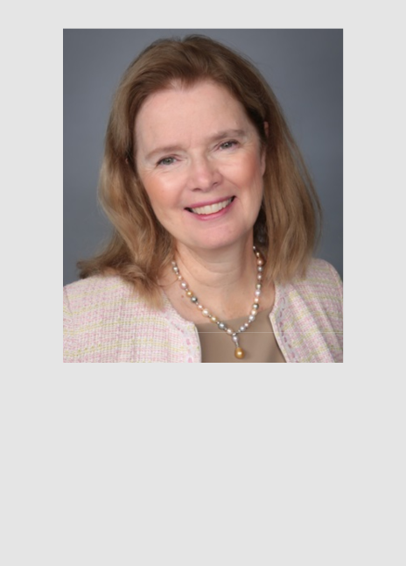

Director

Age: 71

Director since: 2025

Committees:

- Audit Committee (Chair)

- Nominating and Governance Committee


Director

Age: 54

Director since: 2026

Committees:

- Audit Committee

BARBARA M. BYRNE

Ms. Byrne has served as a member of our Board since August 2025. Ms. Byrne is a former Vice Chairman of Investment Banking at Barclays PLC and a former Vice Chairman of Lehman Brothers. Ms. Byrne served as a member of the boards of Paramount Global and its predecessor CBS Corporation since 2018 when she retired from investment banking. Ms. Byrne has served as a director of LanzaTech NZ Inc since 2023 and of Carta, Inc. since

2021. She previously served on the boards of Power School Holdings, Inc., Hennessy Capital Investment Corp. V and Slam Corp. She is also a Lifetime Member of the Council on Foreign Relations and the Audit Committee Leadership Network. She previously served as an Executive in Residence at Columbia Business School, a Trustee of the Institute of International Education, a Trustee of Mount Holyoke College and a member of the Investment Committee of Catalyst. We believe Ms. Byrne is qualified to serve as a member of our Board because of her more than 40 years of financial services experience and extensive business and financial expertise in complex transactions, risk management, strategy and other financial matters.

ANDREW CAMPION

Mr. Campion has served as a member of our Board since January 2026. Mr. Campion currently serves as Chairman of Unrivaled Sports. Previously, Mr. Campion held executive leadership roles at Nike over 17 years, including Chief Operating Officer, Chief Financial Officer and head of global strategy. Prior to Nike, Mr. Campion spent over 11 years with The Walt Disney Company, most recently serving as Senior Vice President of Corporate Development after prior leadership and management roles across global strategic planning, mergers and acquisitions, financial planning and analysis, operations planning, investor relations, and tax. Mr. Campion also currently serves on the boards of directors of Starbucks, Williams-Sonoma, Inc., Vuori, the Los Angeles 2028 Olympic and Paralympic Games, and the UCLA Anderson School of Management. He also founded, serves as a professor, and is the Director of UCLA’s Sports Leadership and Management Program. Mr. Campion and his wife are minority owners of the Real Salt Lake and Utah Royals professional soccer teams. We believe Mr. Campion is qualified to serve as a member of our Board because of his extensive experience in the public company sector, including expertise in business growth strategies and enterprise financial management.

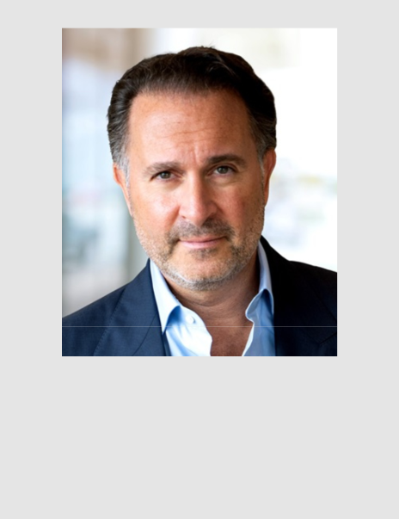
GERALD CARDINALE

Mr. Cardinale has served as a member of our Board since August 2025. Mr. Cardinale is the founder of RedBird Capital Partners Management LLC and has served as its Managing Partner and Chief Investment Officer since 2014. Prior to founding RedBird Capital Partners Management LLC, Mr. Cardinale spent over 20 years at Goldman Sachs where he was a Partner from 2004 to 2012. We believe Mr. Cardinale is qualified to serve as a member of our Board because of his extensive investment and management experience specifically in the sports, media and entertainment industries and his extensive experience serving in a role as director.

Director

Age: 59

Director since: 2025

Committees:

- Compensation Committee (Chair)
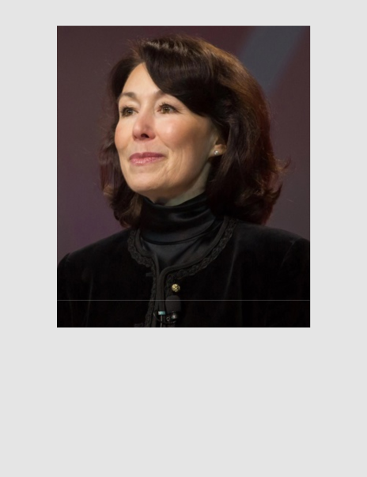

SAFRA A. CATZ

Ms. Catz has served as a member of our Board since August 2025. Ms. Catz has been the Executive Vice Chair of Oracle Corporation since September 22, 2025, and has been a member of Oracle’s board of directors since 2001. At Oracle, Ms. Catz previously served as Chief Executive Officer, President, Chief Financial Officer, Executive Vice President, and Senior Vice President. Ms. Catz also previously served on the board of directors of The Walt Disney Company from 2018 to 2024. Prior to joining Oracle, Ms. Catz developed deep technology industry experience as a managing director with the investment banking firm Donaldson, Lufkin & Jenrette covering the technology industry. We believe Ms. Catz is qualified to serve as a member of our Board because of her extensive experience serving as an executive and director of large, complex global organizations and her valuable insight regarding the technology industry generally.

Director

Age: 64

Director since: 2025

Committees:

- Compensation Committee

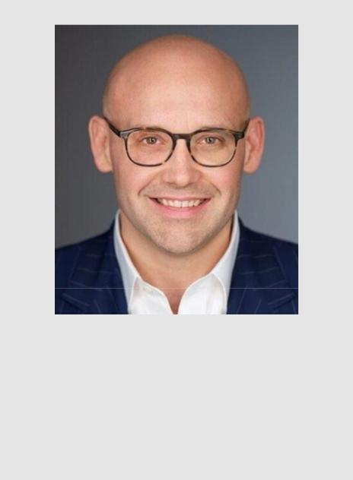

Director

Age: 48

Director since: 2025

Committees:

- Audit Committee

- Compensation Committee
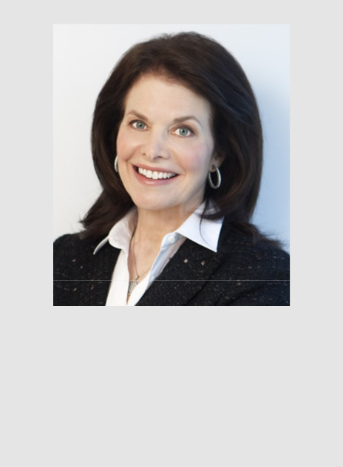

Director

Age: 81

Director since: 2025

Committees:

- Nominating and Governance Committee (Chair)

JUSTIN G. HAMILL

Mr. Hamill has served as a member of our Board since August 2025. Mr. Hamill is a Managing Director and the Chief Legal Officer at Silver Lake, a leading global technology investment firm. Prior to joining Silver Lake, Mr. Hamill served as Global Chair of M&A at Latham & Watkins LLP, a leading global law firm, where he advised public and private companies, investment funds, and financial institutions in negotiated and contested M&A transactions, leveraged buyouts, joint ventures, public and private investments, and restructurings. We believe Mr. Hamill is qualified to serve as a member of our Board because of his significant knowledge and expertise in advising public companies and their board rooms gained over years of representing clients in high-stakes transactions.

SHERRY LANSING

Ms. Lansing has served as a member of our Board since August 2025. Ms. Lansing currently serves as Chairman of the board of directors of Universal Music Group. During almost 30 years in the motion picture business, Ms. Lansing played a key role in the production, marketing, and distribution of more than 200 films, including Academy Award winners Forrest Gump, Braveheart, and Titanic. In 1980, Ms. Lansing became the first woman to head a major film studio when she was appointed President of 20th Century Fox. Later, as an independent producer, Ms. Lansing was responsible for successful films such as Fatal Attraction, The Accused, School Ties, Indecent Proposal, and Black Rain. Returning to the executive ranks in 1992, she was named Chairman and CEO of Paramount Pictures and began an unprecedented tenure in that role that lasted more than 12 years (1992-2005). A dedicated philanthropist, in 2005, Ms. Lansing founded the Sherry Lansing Foundation, a nonprofit organization dedicated to cancer research, health, public education, and encore career opportunities, where she acts as Chief Executive Officer. In addition, Ms. Lansing serves on the boards of the Broad Museum, the Carter Center, the Entertainment Industry Foundation, the W.M. Keck Foundation, the Lasker Foundation, and Scripps Research and as a Trustee of Big Brothers Big Sisters of Greater Los Angeles. We believe Ms. Lansing is qualified to serve as a member of our Board because of her knowledge of Paramount’s studio and extensive experience in creative, executive and leadership roles, including as a director, at entertainment, media and content production companies.



Director

Age: 59

Director since: 2025

Committees:

- Nominating and Governance Committee
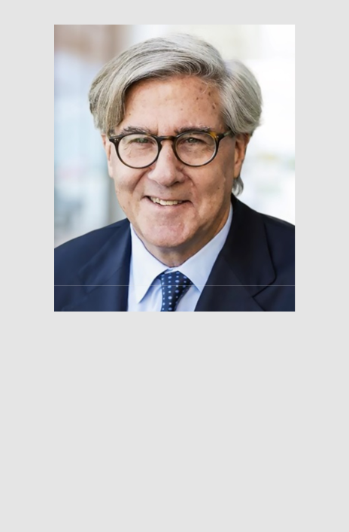

Director

Age: 72

Director since: 2025

Committees:

- Nominating and Governance Committee

PAUL MARINELLI

Mr. Marinelli has served as a member of our Board since August 2025. Mr. Marinelli has served as President of Lawrence Investments, LLC, an investment firm owned by Lawrence J. Ellison, since 2015, and as Vice President from 2004 to 2015. From 1994 to 2004, he held various corporate development and finance positions at Cadence Design Systems, Inc., an electronic design automation software and services company, PricewaterhouseCoopers, a global professional services firm, and Emcon Services, Inc., an environmental engineering firm. Mr. Marinelli serves or has served as a director of several companies, including Skydance, Imagene AI Ltd., a precision oncology company using artificial intelligence to support personalized cancer treatment, Sensei Farms, a sustainable agriculture and innovative farming company, Autonomous Medical Devices Inc., a medical diagnostics company, LeapFrog Enterprises, a developer of educational entertainment for children, and Harbor Lights Entertainment, Inc. We believe that Mr. Marinelli is qualified to serve as a member of our Board because of his extensive experience in finance and business development.

JOHN L. THORNTON

Mr. Thornton has served as a member of our Board since August 2025. Mr. Thornton has served as Chairman of RedBird Capital Partners Management LLC since August 2023. Mr. Thornton is also Chairman of Barrick Mining Corporation and non-executive Chairman of Heron View Investments, L.P., a global investment firm. Mr. Thornton also serves as lead independent director on the boards of Ford Motor Company and Lenovo Group Limited.

Mr. Thornton is a professor and director of Tsinghua University’s Global Leadership Program, and an advisory board member of Tsinghua’s School of Economics and Management and its School of Public Policy and Management. Mr. Thornton is co-chair of the Asia Society, chairman emeritus of the Brookings Institution in Washington, D.C., and is also on the advisory boards or board of trustees of African Leadership Academy, China Investment Corporation (CIC), China Securities Regulatory Commission, King Abdullah University of Science and Technology, McKinsey Advisory Council and Schwarzman Scholars. Mr. Thornton joined Goldman Sachs in 1980 and retired as president and director of The Goldman Sachs Group, Inc. in 2003. He also previously served as chairman of Goldman Sachs Asia and as co-chief executive of Goldman Sachs International, overseeing the firm’s business in Europe, the Middle East, and Africa.

Mr. Thornton has also served as a director on the boards of BSkyB, China Unicom, DirecTV, HSBC, ICBC, IMG, Intel and News Corp. We believe Mr. Thornton is qualified to serve as a member of our Board because of his extensive investment and management experience and his extensive experience serving in a role as director.

PROPOSAL 2 – RATIFICATION OF THE APPOINTMENT OF THE INDEPENDENT REGISTERED PUBLIC ACCOUNTING FIRM

The Audit Committee of our Board of Directors has appointed PwC as our independent registered public accounting firm for the year ending December 31, 2026.

The Audit Committee has reviewed PwC’s independence from the Company. In appointing PwC as our independent registered public accounting firm for the year ending December 31, 2026, and in recommending that our stockholders ratify the appointment, the Audit Committee has considered whether the non-audit services provided by PwC were compatible with maintaining PwC’s independence from the Company and has determined that such services do not impair PwC’s independence.

Neither our governing documents nor applicable law require stockholder ratification of the selection of PwC as our independent registered public accounting firm. However, we are submitting this proposal to our stockholders as a matter of good corporate practice. If the stockholders fail to ratify the selection, the Audit Committee will reconsider whether or not to retain that firm. Even if the selection is ratified, the Audit Committee, in its discretion, may direct the appointment of different independent auditors at any time during the year if they determine that such a change would be in the best interests of Paramount and its stockholders.

Makan Delrahim

Chief Legal Officer

